Gidgegannup Dressage Club Inc.
PO Box 29
Mundaring, WA 6073

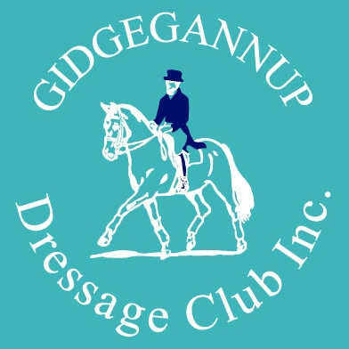

GUEST MEMBERSHIP

WHAT IS THE GUEST MEMBERSHIP?
An opportunity to hone your Dressage skills by participating in one of the Gidgegannup Dressage Club rallies.
A chance to meet and greet the club’s friendly and supportive members and committee by participating in a rally with your horse.
An opportunity to train with some of Western Australia’s most respected instructors.
Exposure for yourself and your horse to a lesson in a safe and secure environment.

COME AND TRY the GUEST MEMBERSHIP offered by the Gidgegannup Dressage Club Inc.

HOW DOES IT WORK?
You can now join the Gidgegannup Dressage Club for ONE of their rallies (per calendar year) for only $10 day membership fee plus $35 per lesson!

TERMS AND CONDITIONS
If you are interested, you must be:
  - Minimum of 18 years of age
  - Register your interest with our Rally Coordinator Cassandra Rozema via email to cassrally@gmail.com a minimum of a fortnight before the rally
  - Sign a EWA Member’s Dangerous Activity Form, as well as a AON Insurance’s Release and Waiver Form in advance of the rally (both found on our website)
- Guest Memberships per rally may be limited, and are awarded first-come-first-serve
- Guest Members may opt to have one or two lessons on the rally day.
- The Rally Form, Payment and other required forms must be returned by the rally closing date, together with full payment (our standard Refund Policy applies)
- Only ONE available per calendar year/per rider
- The $10 Guest Membership fee will be discounted from the Membership fee applicable at the time, if the person becomes a financial member on the day of the rally.

